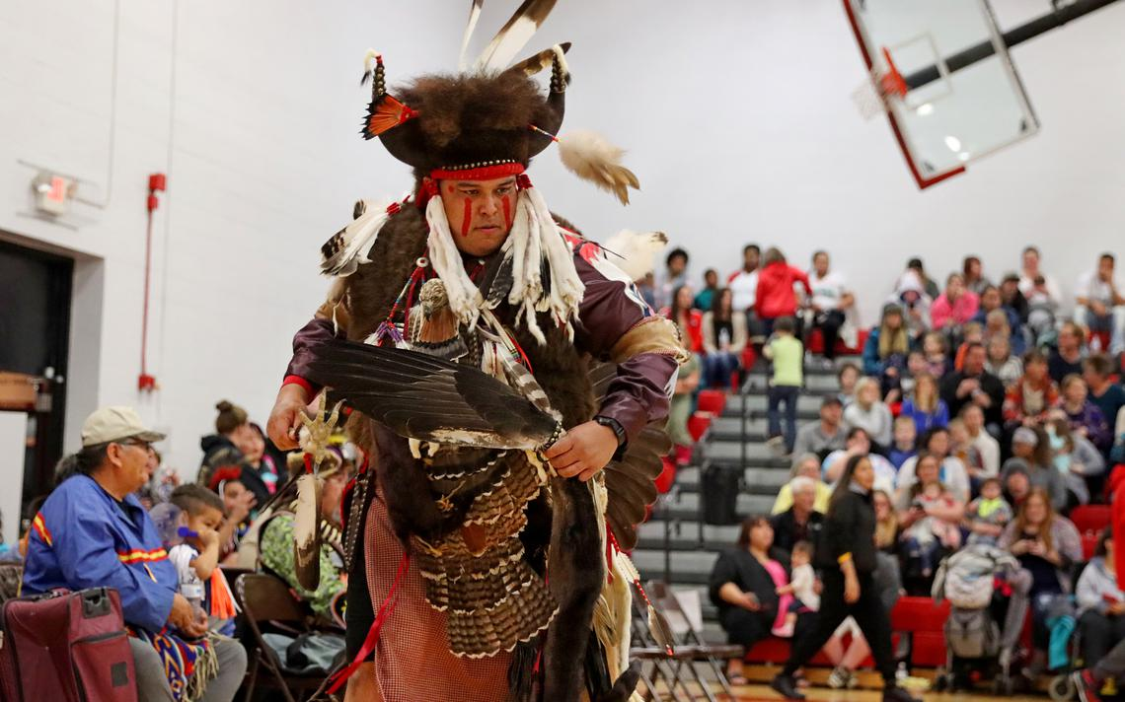
My name is Marcus Greatshield. I’m from South Dakota and a member of the Yankton Sioux Tribe. I dance the men’s traditional style, the old warrior style. I dance all over the country with my wife and 3 children who are also dancers. When I dance, I’m dancing for our ancestors, the people of today and tomorrow to carry on our traditions. When I’m dancing in the sacred circle with my sacred regalia and feathers, I’m praying and making medicine for the sacred circle, for the people, for me and you. I’m making medicine for the earth and all that walk it, whether they be two or four legged, regardless of race or religion. When I say making medicine, I mean spiritual medicine. I hope to inspire both the youth and adults when I’m dancing at any Wacipi (Pow-Wow). I hope that it brings them all happiness. I dance because I was called by the drum to do so. It called my heart to the sacred circle….and in the sacred circle it will remain.
I would like to thank the Liberty Wildlife Non-Eagle Feather Repository Program for providing me with the beautiful feathers that I consider to be sacred, that I use for many different ceremonial practices. These feathers and the Program mean a lot to me and I’m truly grateful for the staff and Program that serve thousands of indigenous people like myself.
Hoka Hey,
Marcus Greatshield.
Special note – Marcus has been receiving feathers from the Liberty Wildlife Non-Eagle Feather Repository since 2013. We have supported Marcus’s calling for 7 years and plan to continue into the future.

